NORTH POINT SENIOR SECONDARY BOARDING SCHOOL

WORKSHEET
CLASS - NURSERY

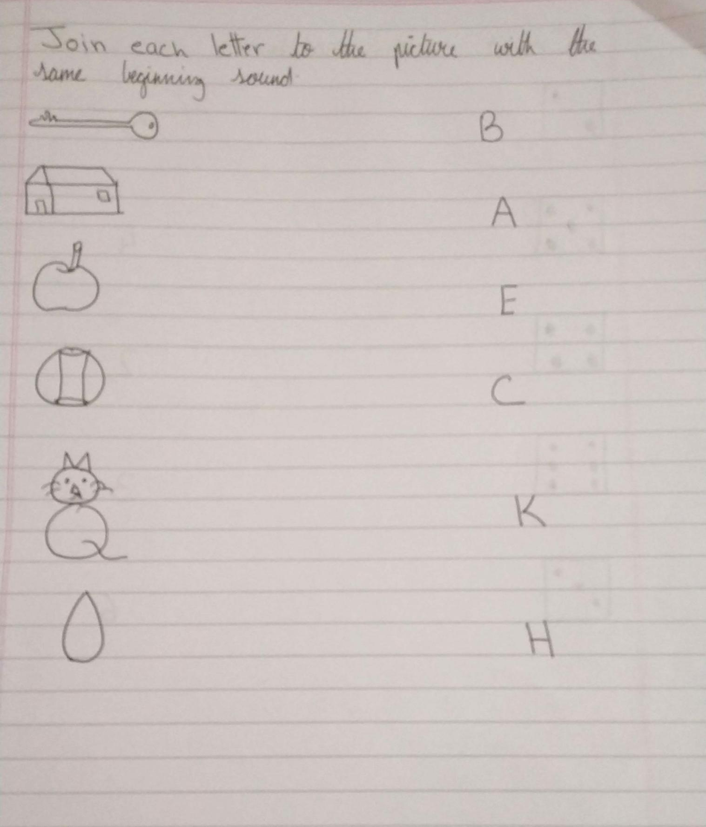
ENGLISH

